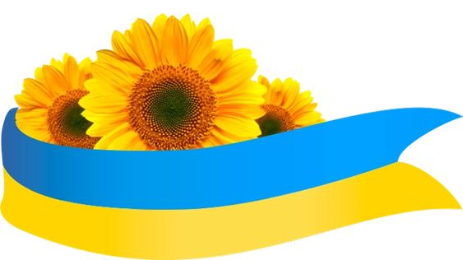
Святкування Дня Незалежності України
Ukraine Independence Day Event
The Con Club in Lewes
Friday 25th August 2023 starts at 7pm
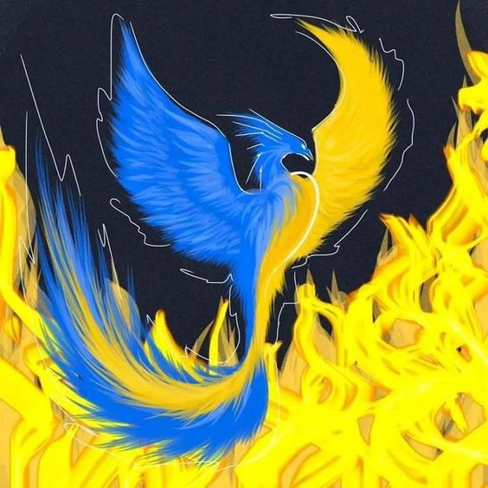
Come to a free cultural evening of Ukrainian music and folk dancing. Enjoy this evening of our Ukrainian friends hospitality. Ukrainian food will be provided.

